**Project Design Phase**

**Solution Architecture**

|  |  |
| --- | --- |
| Date | 16 April 2025 |
| Team ID | SWTID1743513717 |
| Project Name | SB Foods – MERN Stack Food Ordering Web App |
| Maximum Marks | 4 Marks |

**Solution Architecture:**

SB Foods is built using the MERN (MongoDB, Express.js, React.js, Node.js) stack, which provides a scalable, full-stack JavaScript solution. The architecture is designed to separate concerns across three main layers:

1. Frontend (React.js):

* Users interact with the UI to register, login, browse food categories, add items to the cart, and simulate checkout.
* The React application uses React Router for navigation and Context API for global cart state management.
* Bootstrap and custom CSS are used for responsive design.

1. Backend (Node.js + Express.js):

* REST APIs handle authentication, user registration, login, order placement, and food item fetching.
* JSON Web Tokens (JWT) are used to manage user sessions securely.
* APIs respond to requests from the frontend and perform validation, authorization, and database operations.

1. Database (MongoDB):

* Stores user data, food items (with category, price, and image), and orders.
* Supports document-oriented storage with flexible schemas, ideal for application evolution.

1. Data Flow:

* The client (React) sends HTTP requests to Express.js routes.
* The server validates input and fetches/updates MongoDB collections.
* Responses are sent back to the frontend, which renders the appropriate UI components.

1. Additional Components:

* Simulated payment logic via frontend alerts.
* Order history is displayed using queries to the order collection.
* Admin authentication (if extended) allows food data management.

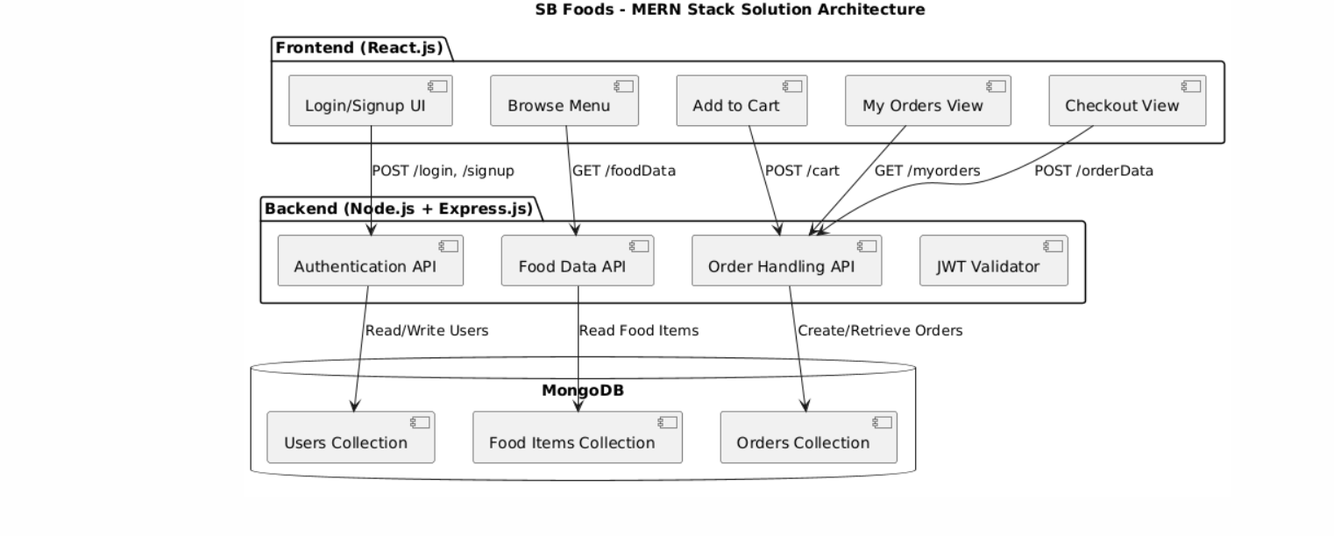**Solution Architecture Diagram:**

*Figure 1: Architecture of the application*